OGME
Oil and Gas Measurement Equipment
“Servicing the oilfield since 1998”
Phone: 713-263-9740
Fax: 713-263-9741
Email: sales@ogme.net
Or visit us at ogme.net

Temporary or Start-Up Strainers

Temporary strainers are designed for use in process system, plants, compressors, refineries, and pipelines. This type of strainer should be installed prior to bringing the equipment on-stream to insure that the normal debris associated with equipment instillation such as pipe scale, rust, weld, and slag do not contaminate the product or damage the plant or equipment. Typically, these strainers are not recommended for extended service due to their light gauge construction, low cost, and ease of replacement.

- Sizes range from ¼” to 60” nominal pipe size
- Range in open area of strainer to cross section area of the pipe from 100% to 300%
- Material gauge thickness of strainer ranges between 22 and 11 depending on hole size
- Perforation hole size range from 1/16” to ¼” as standard
- Material include carbon steel, various grades of S.S., hastelloy, inconel, and titanium
- Strainer support rings can be constructed to accommodate raised face flanges, ring type joint flanges, or any other standard flange facing
- Liners and covers available for small particle removal 200 thru 10 mesh

Dimensions and Percent Open Area
Size | 100% A | 100% B | 150% A | 150% B | 200% A | 200% B | 300% A | 300% B | C
0.75 | 3.00 | 1.50 | 4.00 | 2.00 | 5.00 | 3.00 | 6.00 | 4.00 | 0.38
1.00 | 3.00 | 1.50 | 4.00 | 2.00 | 5.00 | 3.00 | 6.00 | 4.00 | 0.50
1.50 | 3.50 | 2.00 | 4.50 | 2.50 | 6.00 | 3.50 | 9.00 | 5.00 | 0.75
2.00 | 4.00 | 2.50 | 6.00 | 3.00 | 8.00 | 4.00 | 11.00 | 6.00 | 1.00
2.50 | 4.00 | 2.50 | 6.00 | 3.00 | 8.00 | 4.00 | 11.00 | 6.00 | 1.25
3.00 | 5.00 | 3.00 | 7.00 | 4.50 | 9.00 | 6.00 | 13.00 | 8.00 | 1.50
4.00 | 8.00 | 4.00 | 10.00 | 5.00 | 12.00 | 7.00 | 18.00 | 11.00 | 2.00
6.00 | 9.00 | 5.50 | 13.00 | 8.00 | 18.00 | 11.00 | 25.00 | 17.00 | 3.00
8.00 | 12.00 | 7.00 | 17.00 | 11.00 | 23.00 | 14.00 | 33.00 | 21.00 | 4.00
10.00 | 14.00 | 8.00 | 21.00 | 13.00 | 28.00 | 17.00 | 41.00 | 26.00 | 5.00
12.00 | 16.00 | 10.00 | 25.00 | 15.00 | 34.00 | 20.00 | 49.00 | 31.00 | 6.00
14.00 | 18.00 | 10.00 | 27.00 | 16.00 | 36.00 | 22.00 | 53.00 | 33.00 | 7.00
16.00 | 21.00 | 12.00 | 31.00 | 19.00 | 40.00 | 24.00 | 61.00 | 37.00 | 8.00
18.00 | 24.00 | 14.00 | 35.00 | 21.00 | 46.00 | 27.00 | 68.00 | 41.00 | 9.00
20.00 | 26.00 | 16.00 | 38.00 | 24.00 | 51.00 | 31.00 | 76.00 | 48.00 | 10.00
24.00 | 31.00 | 18.00 | 45.00 | 28.00 | 61.00 | 37.00 | 90.00 | 57.00 | 12.00
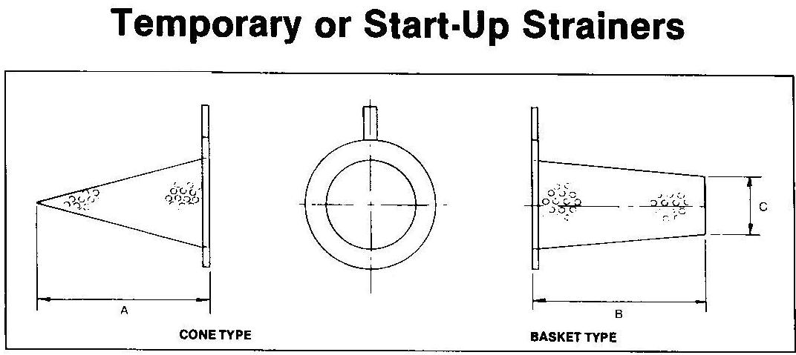

When Ordering Please Specify
- Pipe Size
- Pressure rating/flange size
- Perforation or mesh size
- Material
- Style-cone, basket, or flat
- Direction of flow-normal or reverse
- Percentage of open area

Note: C equals ½ the nominal pipe size. C equal to 5” and larger have inverted cone for strength and increased area.
100% Basket, B designed to fit weld neck flange plus 1-R welding elbow.
Struts, hoops, and bracing for standard cones can be furnished for additional strength.

Caution: Pressure drops are critical in strainer applications and each situation needs to be evaluated on an individual basis

